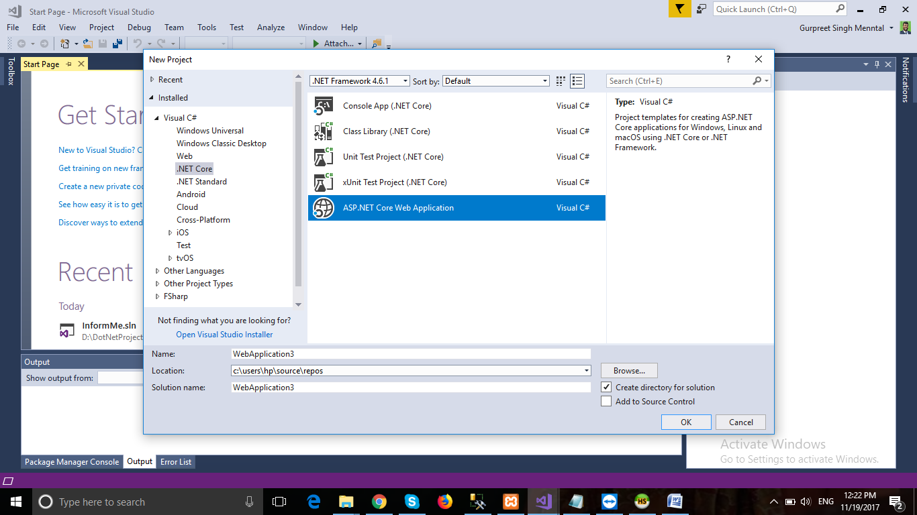

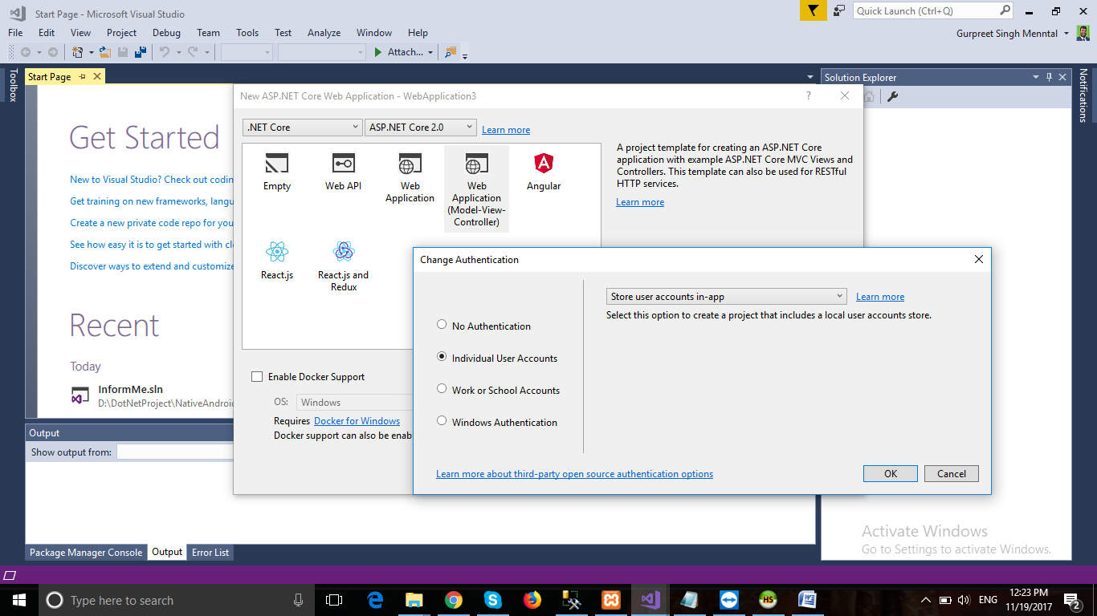

**Create project with**

* **ASP.NET Core Web Application**
* **MVC with Individual User Accounts**
* **Install this from nuget :-**
  + Pomelo.EntityFrameworkCore.MySql
  + Dapper
* **Create database in mysql**
* **Change my sql connection in appsettings.json**
  + "DefaultConnection": "server=localhost;database=Informme;User=root;password=;"
* **Replace**

options.UseSqlServer(Configuration.GetConnectionString("DefaultConnection")));

options. **UseMySql**(Configuration.GetConnectionString("DefaultConnection")));

**Update-database in package manager**

**Data accessing with Dapper**

using InformMeWeb.Database.Models;

using System.Linq;

using Dapper;

using System.Data.SqlClient;

using Pomelo.EntityFrameworkCore.MySql;

using System.Data;

namespace InformMeWeb.Database.Class

{

public class GroupsClass

{

private string connectionString;

public GroupsClass()

{

connectionString = "server=localhost;database=Informme;User=root;password=;";

}

public IDbConnection Connection

{

get

{

return new SqlConnection(connectionString); // SQL Server

return new MySqlConnection(connectionString); //MySql

}

}

public void Insert(Groups prod)

{

using (IDbConnection dbConnection = Connection)

{

string sQuery = "INSERT INTO Products (Name, Quantity, Price)"

+ " VALUES(@Name, @Quantity, @Price)";

dbConnection.Open();

dbConnection.Execute (sQuery, prod);

}

}

public Groups GetById(string id)

{

using (IDbConnection dbConnection = Connection)

{

string sQuery = "SELECT * FROM Groups WHERE GroupId = @Id";

dbConnection.Open();

return dbConnection.Query<Groups>(sQuery, new { Id = id }).FirstOrDefault();

}

}

}

}